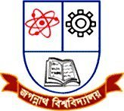
Jagannath University, Dhaka
Department of CSE
Supplementary Examination-2020
Course Code: CSER-2105, Math-III, Ordinary Differential Equations
Full Marks: 10 Time: 30 minutes

Final Examination Year: 2010 Trimester: Summer
Course: Math 155 Title: Ordinary and Partial Differential Equations
Section: B Marks: 30 Time: 1 hour 40 minutes

There are Four questions. Answer any Three of the questions.

1. |  | State and prove existence and uniqueness theorem.
2. |  | Solve the following differential equation by the method of the undetermined coefficients  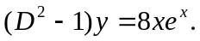
3. |  | If 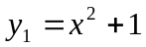 is a solution of differential equation 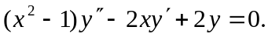 Find the general solution of reducing of order.
4. |  | Apply the method of variation of parameters to solve the differential equation  